Roll No: 1703018

Lab Performance Test 2

Lab Task Q1

Question:

Show an OpenGL program which will show a triangle whose triangle's color will alternate between a red color and blue color after some time.

Solution:

|  |
| --- |
| #*include* "glad.h"  #*include* "glfw3.h"  //*Roll: 1703018*  //*Q1: Show an OpenGL program which will show a triangle whose triangle's color will alternate between a red color and blue color after some time.*  #*include* <iostream>  #*include* <cmath>  void *framebuffer_size_callback*(GLFWwindow*\** window, int width, int height);  void *processInput*(GLFWwindow *\**window);  // *settings*  *const* unsigned int SCR_WIDTH = 800;  *const* unsigned int SCR_HEIGHT = 600;  *const* char *vertexShaderSource ="#version 330 core\n"      "layout (location = 0) in vec3 aPos;\n"      "void main()\n"      "{\n"      "   gl_Position = vec4(aPos, 1.0);\n"      "}\0";  *const* char *fragmentShaderSource = "#version 330 core\n"      "out vec4 FragColor;\n"      "uniform vec4 ourColor;\n"      "void main()\n"      "{\n"      "   FragColor = ourColor;\n"      "}\n\0";  int *main*()  {  // *glfw: initialize and configure*  // *------------------------------*  *glfwInit*();  *glfwWindowHint*(*GLFW_CONTEXT_VERSION_MAJOR*, 3);  *glfwWindowHint*(*GLFW_CONTEXT_VERSION_MINOR*, 3);  *glfwWindowHint*(*GLFW_OPENGL_PROFILE*, *GLFW_OPENGL_CORE_PROFILE*);  #*ifdef* __APPLE__  *glfwWindowHint*(GLFW_OPENGL_FORWARD_COMPAT, GL_TRUE);  #*endif*  // *glfw window creation*  // *--------------------*      GLFWwindow* window = *glfwCreateWindow*(SCR_WIDTH, SCR_HEIGHT, "LearnOpenGL", *NULL*, *NULL*);  *if* (window == *NULL*)      {          std::cout *<<* "Failed to create GLFW window" *<<* std::*endl*;  *glfwTerminate*();  *return* -1;      }  *glfwMakeContextCurrent*(window);  *glfwSetFramebufferSizeCallback*(window, *framebuffer_size_callback*);  // *glad: load all OpenGL function pointers*  // *---------------------------------------*  *if* (!*gladLoadGLLoader*((GLADloadproc)*glfwGetProcAddress*))      {          std::cout *<<* "Failed to initialize GLAD" *<<* std::*endl*;  *return* -1;      }  // *build and compile our shader program*  // *------------------------------------*  // *vertex shader*      unsigned int vertexShader = *glCreateShader*(*GL_VERTEX_SHADER*);  *glShaderSource*(vertexShader, 1, &vertexShaderSource, *NULL*);  *glCompileShader*(vertexShader);  // *check for shader compile errors*      int success;      char infoLog[512];  *glGetShaderiv*(vertexShader, *GL_COMPILE_STATUS*, &success);  *if* (!success)      {  *glGetShaderInfoLog*(vertexShader, 512, *NULL*, infoLog);          std::cout *<<* "ERROR::SHADER::VERTEX::COMPILATION_FAILED\n" *<<* infoLog *<<* std::*endl*;      }  // *fragment shader*      unsigned int fragmentShader = *glCreateShader*(*GL_FRAGMENT_SHADER*);  *glShaderSource*(fragmentShader, 1, &fragmentShaderSource, *NULL*);  *glCompileShader*(fragmentShader);  // *check for shader compile errors*  *glGetShaderiv*(fragmentShader, *GL_COMPILE_STATUS*, &success);  *if* (!success)      {  *glGetShaderInfoLog*(fragmentShader, 512, *NULL*, infoLog);          std::cout *<<* "ERROR::SHADER::FRAGMENT::COMPILATION_FAILED\n" *<<* infoLog *<<* std::*endl*;      }  // *link shaders*      unsigned int shaderProgram = *glCreateProgram*();  *glAttachShader*(shaderProgram, vertexShader);  *glAttachShader*(shaderProgram, fragmentShader);  *glLinkProgram*(shaderProgram);  // *check for linking errors*  *glGetProgramiv*(shaderProgram, *GL_LINK_STATUS*, &success);  *if* (!success) {  *glGetProgramInfoLog*(shaderProgram, 512, *NULL*, infoLog);          std::cout *<<* "ERROR::SHADER::PROGRAM::LINKING_FAILED\n" *<<* infoLog *<<* std::*endl*;      }  *glDeleteShader*(vertexShader);  *glDeleteShader*(fragmentShader);  // *set up vertex data (and buffer(s)) and configure vertex attributes*  // *------------------------------------------------------------------*      float vertices[] = {           0.5f, -0.5f, 0.0f,// *bottom right*          -0.5f, -0.5f, 0.0f,// *bottom left*           0.0f,  0.5f, 0.0f// *top*      };      unsigned int VBO, VAO;  *glGenVertexArrays*(1, &VAO);  *glGenBuffers*(1, &VBO);  // *bind the Vertex Array Object first, then bind and set vertex buffer(s), and then configure vertex attributes(s).*  *glBindVertexArray*(VAO);  *glBindBuffer*(*GL_ARRAY_BUFFER*, VBO);  *glBufferData*(*GL_ARRAY_BUFFER*, sizeof(vertices), vertices, *GL_STATIC_DRAW*);  *glVertexAttribPointer*(0, 3, *GL_FLOAT*, *GL_FALSE*, 3 * sizeof(float), (void*)0);  *glEnableVertexAttribArray*(0);  // *You can unbind the VAO afterwards so other VAO calls won't accidentally modify this VAO, but this rarely happens. Modifying other*  // *VAOs requires a call to glBindVertexArray anyways so we generally don't unbind VAOs (nor VBOs) when it's not directly necessary.*  // *glBindVertexArray(0);*  // *bind the VAO (it was already bound, but just to demonstrate): seeing as we only have a single VAO we can*  // *just bind it beforehand before rendering the respective triangle; this is another approach.*  *glBindVertexArray*(VAO);  // *render loop*  // *-----------*  *while* (!*glfwWindowShouldClose*(window))      {  // *input*  // *-----*  *processInput*(window);  // *render*  // *------*  *glClearColor*(0.2f, 0.3f, 0.3f, 1.0f);  *glClear*(*GL_COLOR_BUFFER_BIT*);  // *be sure to activate the shader before any calls to glUniform*  *glUseProgram*(shaderProgram);  // *update shader uniform*  **double  timeValue = *glfwGetTime*();**  **float redValue = static_cast<float>((*sin*(timeValue)) / 2.0 + 0.5);**  **float blueValue = static_cast<float>((1.0 - *sin*(timeValue)) / 2.0 + 0.5);**          int vertexColorLocation = *glGetUniformLocation*(shaderProgram, "ourColor");  ***glUniform4f*(vertexColorLocation, blueValue, 0.0f, redValue, 1.0f);**  // *render the triangle*  *glDrawArrays*(*GL_TRIANGLES*, 0, 3);  // *glfw: swap buffers and poll IO events (keys pressed/released, mouse moved etc.)*  // *-------------------------------------------------------------------------------*  *glfwSwapBuffers*(window);  *glfwPollEvents*();      }  // *optional: de-allocate all resources once they've outlived their purpose:*  // *------------------------------------------------------------------------*  *glDeleteVertexArrays*(1, &VAO);  *glDeleteBuffers*(1, &VBO);  *glDeleteProgram*(shaderProgram);  // *glfw: terminate, clearing all previously allocated GLFW resources.*  // *------------------------------------------------------------------*  *glfwTerminate*();  *return* 0;  }  // *process all input: query GLFW whether relevant keys are pressed/released this frame and react accordingly*  // *---------------------------------------------------------------------------------------------------------*  void *processInput*(GLFWwindow *\**window)  {  *if* (*glfwGetKey*(window, *GLFW_KEY_ESCAPE*) == *GLFW_PRESS*)  *glfwSetWindowShouldClose*(window, true);  }  // *glfw: whenever the window size changed (by OS or user resize) this callback function executes*  // *---------------------------------------------------------------------------------------------*  void *framebuffer_size_callback*(GLFWwindow*\** window, int width, int height)  {  // *make sure the viewport matches the new window dimensions; note that width and*  // *height will be significantly larger than specified on retina displays.*  *glViewport*(0, 0, width, height);  } |

Output:

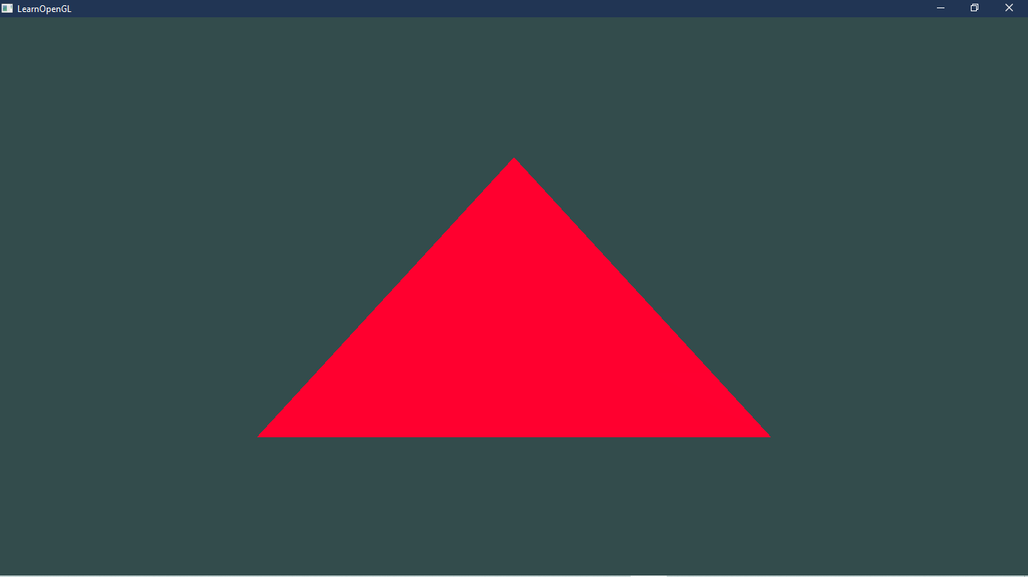

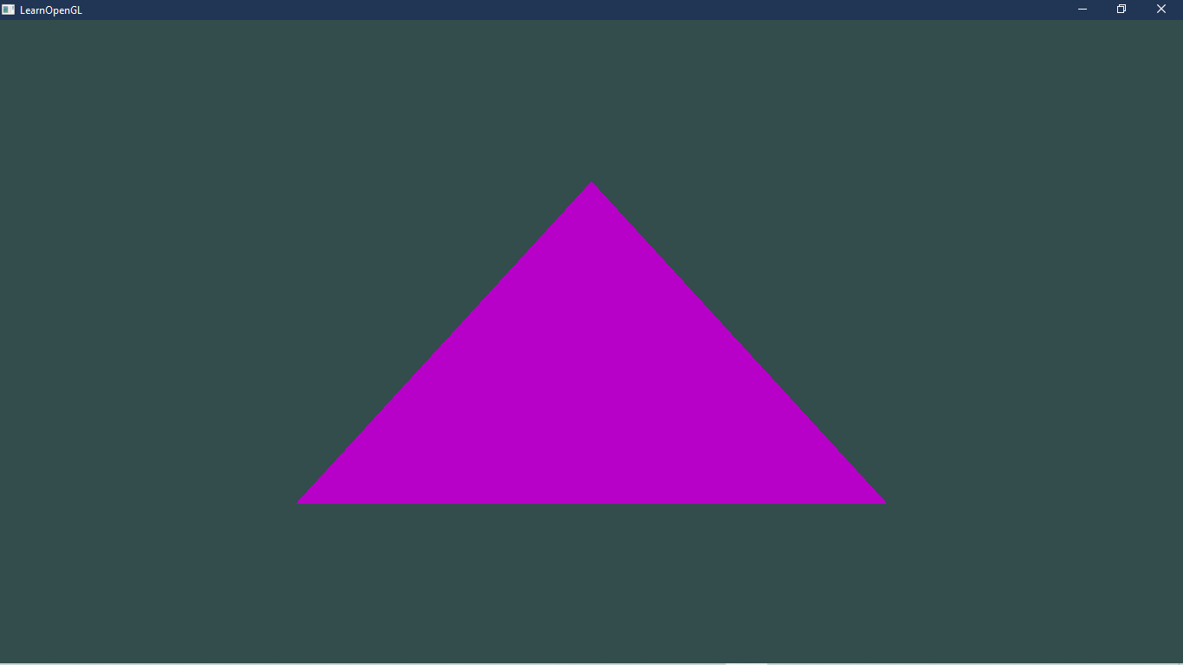

Lab Task Q2

Question:

Show an OpenGL program which will show a 3d pyramid at location (3,10,7) which scaled by 2.5 and is rotated by 90 degree counter-clockwise.

Solution:

|  |
| --- |
| #*include* "glad.h"  #*include* "glfw3.h"  //*Roll: 1703018*  //*Q2: Show an OpenGL program which will show a 3d pyramid at location (3,10,7)  which scaled by 2.5 and is rotated by 90 degree counter-clockwise.*  #*define* *STB_IMAGE_IMPLEMENTATION*  #*include* "stb_image.h"  #*include* "glm/glm.hpp"  #*include* "glm/gtc/matrix_transform.hpp"  #*include* "glm/gtc/type_ptr.hpp"  #*include* "learnopengl/shader_m.h"  #*include* <iostream>  void *framebuffer_size_callback*(GLFWwindow*\** window, int width, int height);  void *processInput*(GLFWwindow *\**window);  // *settings*  *const* unsigned int SCR_WIDTH = 800;  *const* unsigned int SCR_HEIGHT = 600;  int *main*()  {  // *glfw: initialize and configure*  // *------------------------------*  *glfwInit*();  *glfwWindowHint*(*GLFW_CONTEXT_VERSION_MAJOR*, 3);  *glfwWindowHint*(*GLFW_CONTEXT_VERSION_MINOR*, 3);  *glfwWindowHint*(*GLFW_OPENGL_PROFILE*, *GLFW_OPENGL_CORE_PROFILE*);  #*ifdef* __APPLE__  *glfwWindowHint*(GLFW_OPENGL_FORWARD_COMPAT, GL_TRUE);  #*endif*  // *glfw window creation*  // *--------------------*      GLFWwindow* window = *glfwCreateWindow*(SCR_WIDTH, SCR_HEIGHT, "LearnOpenGL", *NULL*, *NULL*);  *if* (window == *NULL*)      {          std::cout *<<* "Failed to create GLFW window" *<<* std::*endl*;  *glfwTerminate*();  *return* -1;      }  *glfwMakeContextCurrent*(window);  *glfwSetFramebufferSizeCallback*(window, *framebuffer_size_callback*);  // *glad: load all OpenGL function pointers*  // *---------------------------------------*  *if* (!*gladLoadGLLoader*((GLADloadproc)*glfwGetProcAddress*))      {          std::cout *<<* "Failed to initialize GLAD" *<<* std::*endl*;  *return* -1;      }  // *configure global opengl state*  // *-----------------------------*  *glEnable*(*GL_DEPTH_TEST*);  // *build and compile our shader zprogram*  // *------------------------------------*      Shader *ourShader*("src/shader/6.2.coordinate_systems.vs", "src/shader/6.2.coordinate_systems.fs");  // *set up vertex data (and buffer(s)) and configure vertex attributes*  // *------------------------------------------------------------------*      float vertices[] = {  **-0.5f, -0.5f, -0.5f,  0.0f, 0.0f,**  **0.5f, -0.5f, -0.5f,  1.0f, 0.0f,**  **0.5f,  0.5f, -0.5f,  1.0f, 1.0f,**  **0.5f,  0.5f, -0.5f,  1.0f, 1.0f,**  **-0.5f,  0.5f, -0.5f,  0.0f, 1.0f,**  **-0.5f, -0.5f, -0.5f,  0.0f, 0.0f,**  **-0.5f, -0.5f,  0.5f,  0.0f, 0.0f,**  **0.5f, -0.5f,  0.5f,  1.0f, 0.0f,**  **0.5f,  0.5f,  0.5f,  1.0f, 1.0f,**  **0.5f,  0.5f,  0.5f,  1.0f, 1.0f,**  **-0.5f,  0.5f,  0.5f,  0.0f, 1.0f,**  **-0.5f, -0.5f,  0.5f,  0.0f, 0.0f,**  **-0.5f,  0.5f,  0.5f,  1.0f, 0.0f,**  **-0.5f,  0.5f, -0.5f,  1.0f, 1.0f,**  **-0.5f, -0.5f, -0.5f,  0.0f, 1.0f,**  **-0.5f, -0.5f, -0.5f,  0.0f, 1.0f,**  **-0.5f, -0.5f,  0.5f,  0.0f, 0.0f,**  **-0.5f,  0.5f,  0.5f,  1.0f, 0.0f,**  **0.5f,  0.5f,  0.5f,  1.0f, 0.0f,**  **0.5f,  0.5f, -0.5f,  1.0f, 1.0f,**  **0.5f, -0.5f, -0.5f,  0.0f, 1.0f,**  **0.5f, -0.5f, -0.5f,  0.0f, 1.0f,**  **0.5f, -0.5f,  0.5f,  0.0f, 0.0f,**  **0.5f,  0.5f,  0.5f,  1.0f, 0.0f,**  /\**-0.5f, -0.5f, -0.5f,  0.0f, 1.0f,*  *0.5f, -0.5f, -0.5f,  1.0f, 1.0f,*  *0.5f, -0.5f,  0.5f,  1.0f, 0.0f,*  *0.5f, -0.5f,  0.5f,  1.0f, 0.0f,*  *-0.5f, -0.5f,  0.5f,  0.0f, 0.0f,*  *-0.5f, -0.5f, -0.5f,  0.0f, 1.0f,*  *-0.5f,  0.5f, -0.5f,  0.0f, 1.0f,*  *0.5f,  0.5f, -0.5f,  1.0f, 1.0f,*  *0.5f,  0.5f,  0.5f,  1.0f, 0.0f,*  *0.5f,  0.5f,  0.5f,  1.0f, 0.0f,*  *-0.5f,  0.5f,  0.5f,  0.0f, 0.0f,*  *-0.5f,  0.5f, -0.5f,  0.0f, 1.0f*\*/      };      unsigned int VBO, VAO;  *glGenVertexArrays*(1, &VAO);  *glGenBuffers*(1, &VBO);  *glBindVertexArray*(VAO);  *glBindBuffer*(*GL_ARRAY_BUFFER*, VBO);  *glBufferData*(*GL_ARRAY_BUFFER*, sizeof(vertices), vertices, *GL_STATIC_DRAW*);  // *position attribute*  *glVertexAttribPointer*(0, 3, *GL_FLOAT*, *GL_FALSE*, 5 * sizeof(float), (void*)0);  *glEnableVertexAttribArray*(0);  // *texture coord attribute*  *glVertexAttribPointer*(1, 2, *GL_FLOAT*, *GL_FALSE*, 5 * sizeof(float), (void*)(3 * sizeof(float)));  *glEnableVertexAttribArray*(1);  // *load and create a texture*  // *-------------------------*      unsigned int texture1, texture2;  // *texture 1*  // *---------*  *glGenTextures*(1, &texture1);  *glBindTexture*(*GL_TEXTURE_2D*, texture1);  // *set the texture wrapping parameters*  *glTexParameteri*(*GL_TEXTURE_2D*, *GL_TEXTURE_WRAP_S*, *GL_REPEAT*);  *glTexParameteri*(*GL_TEXTURE_2D*, *GL_TEXTURE_WRAP_T*, *GL_REPEAT*);  // *set texture filtering parameters*  *glTexParameteri*(*GL_TEXTURE_2D*, *GL_TEXTURE_MIN_FILTER*, *GL_LINEAR*);  *glTexParameteri*(*GL_TEXTURE_2D*, *GL_TEXTURE_MAG_FILTER*, *GL_LINEAR*);  // *load image, create texture and generate mipmaps*      int width, height, nrChannels;  *stbi_set_flip_vertically_on_load*(true);// *tell stb_image.h to flip loaded texture's on the y-axis.*      unsigned char *data = *stbi_load*("resources//textures//container.jpg", &width, &height, &nrChannels, 0);  *if* (data)      {  *glTexImage2D*(*GL_TEXTURE_2D*, 0, *GL_RGB*, width, height, 0, *GL_RGB*, *GL_UNSIGNED_BYTE*, data);  *glGenerateMipmap*(*GL_TEXTURE_2D*);      }  *else*      {          std::cout *<<* "Failed to load texture" *<<* std::*endl*;      }  *stbi_image_free*(data);  // *texture 2*  // *---------*  *glGenTextures*(1, &texture2);  *glBindTexture*(*GL_TEXTURE_2D*, texture2);  // *set the texture wrapping parameters*  *glTexParameteri*(*GL_TEXTURE_2D*, *GL_TEXTURE_WRAP_S*, *GL_REPEAT*);  *glTexParameteri*(*GL_TEXTURE_2D*, *GL_TEXTURE_WRAP_T*, *GL_REPEAT*);  // *set texture filtering parameters*  *glTexParameteri*(*GL_TEXTURE_2D*, *GL_TEXTURE_MIN_FILTER*, *GL_LINEAR*);  *glTexParameteri*(*GL_TEXTURE_2D*, *GL_TEXTURE_MAG_FILTER*, *GL_LINEAR*);  // *load image, create texture and generate mipmaps*      data = *stbi_load*("resources//textures//awesomeface.png", &width, &height, &nrChannels, 0);  *if* (data)      {  // *note that the awesomeface.png has transparency and thus an alpha channel, so make sure to tell OpenGL the data type is of GL_RGBA*  *glTexImage2D*(*GL_TEXTURE_2D*, 0, *GL_RGB*, width, height, 0, *GL_RGBA*, *GL_UNSIGNED_BYTE*, data);  *glGenerateMipmap*(*GL_TEXTURE_2D*);      }  *else*      {          std::cout *<<* "Failed to load texture" *<<* std::*endl*;      }  *stbi_image_free*(data);  // *tell opengl for each sampler to which texture unit it belongs to (only has to be done once)*  // *-------------------------------------------------------------------------------------------*      ourShader.*use*();      ourShader.*setInt*("texture1", 0);      ourShader.*setInt*("texture2", 1);  // *render loop*  // *-----------*  *while* (!*glfwWindowShouldClose*(window))      {  // *input*  // *-----*  *processInput*(window);  // *render*  // *------*  *glClearColor*(0.2f, 0.3f, 0.3f, 1.0f);  *glClear*(*GL_COLOR_BUFFER_BIT* | *GL_DEPTH_BUFFER_BIT*);// *also clear the depth buffer now!*  // *bind textures on corresponding texture units*  *glActiveTexture*(*GL_TEXTURE0*);  *glBindTexture*(*GL_TEXTURE_2D*, texture1);  *glActiveTexture*(*GL_TEXTURE1*);  *glBindTexture*(*GL_TEXTURE_2D*, texture2);  // *activate shader*          ourShader.*use*();  // *create transformations*          glm::mat4 model         = glm::*mat4*(1.0f);// *make sure to initialize matrix to identity matrix first*          glm::mat4 view          = glm::*mat4*(1.0f);          glm::mat4 projection    = glm::*mat4*(1.0f);  **model *=* glm::*translate*(model, glm::*vec3*(0.3f, 1.0f, 0.7f));**  **model *=* glm::*rotate*(model, (float)glm::*radians*(90.0f), glm::*vec3*(1.0f, 1.0f, 1.0f));//*counter clockwise***  **//*model = glm::rotate(model, (float)glfwGetTime(), glm::vec3(0.5f, 1.0f, 0.0f));***  **view  *=* glm::*translate*(view, glm::*vec3*(0.0f, 0.0f, -2.5f));**          projection *=* glm::*perspective*(glm::*radians*(45.0f), (float)SCR_WIDTH / (float)SCR_HEIGHT, 0.1f, 100.0f);  // *retrieve the matrix uniform locations*          unsigned int modelLoc = *glGetUniformLocation*(ourShader.ID, "model");          unsigned int viewLoc  = *glGetUniformLocation*(ourShader.ID, "view");  // *pass them to the shaders (3 different ways)*  *glUniformMatrix4fv*(modelLoc, 1, *GL_FALSE*, glm::*value_ptr*(model));  *glUniformMatrix4fv*(viewLoc, 1, *GL_FALSE*, &view*[*0*][*0*]*);  // *note: currently we set the projection matrix each frame, but since the projection matrix rarely changes it's often best practice to set it outside the main loop only once.*          ourShader.*setMat4*("projection", projection);  // *render box*  *glBindVertexArray*(VAO);  *glDrawArrays*(*GL_TRIANGLES*, 0, 36);  // *glfw: swap buffers and poll IO events (keys pressed/released, mouse moved etc.)*  // *-------------------------------------------------------------------------------*  *glfwSwapBuffers*(window);  *glfwPollEvents*();      }  // *optional: de-allocate all resources once they've outlived their purpose:*  // *------------------------------------------------------------------------*  *glDeleteVertexArrays*(1, &VAO);  *glDeleteBuffers*(1, &VBO);  // *glfw: terminate, clearing all previously allocated GLFW resources.*  // *------------------------------------------------------------------*  *glfwTerminate*();  *return* 0;  }  // *process all input: query GLFW whether relevant keys are pressed/released this frame and react accordingly*  // *---------------------------------------------------------------------------------------------------------*  void *processInput*(GLFWwindow *\**window)  {  *if* (*glfwGetKey*(window, *GLFW_KEY_ESCAPE*) == *GLFW_PRESS*)  *glfwSetWindowShouldClose*(window, true);  }  // *glfw: whenever the window size changed (by OS or user resize) this callback function executes*  // *---------------------------------------------------------------------------------------------*  void *framebuffer_size_callback*(GLFWwindow*\** window, int width, int height)  {  // *make sure the viewport matches the new window dimensions; note that width and*  // *height will be significantly larger than specified on retina displays.*  *glViewport*(0, 0, width, height);  } |

Output:

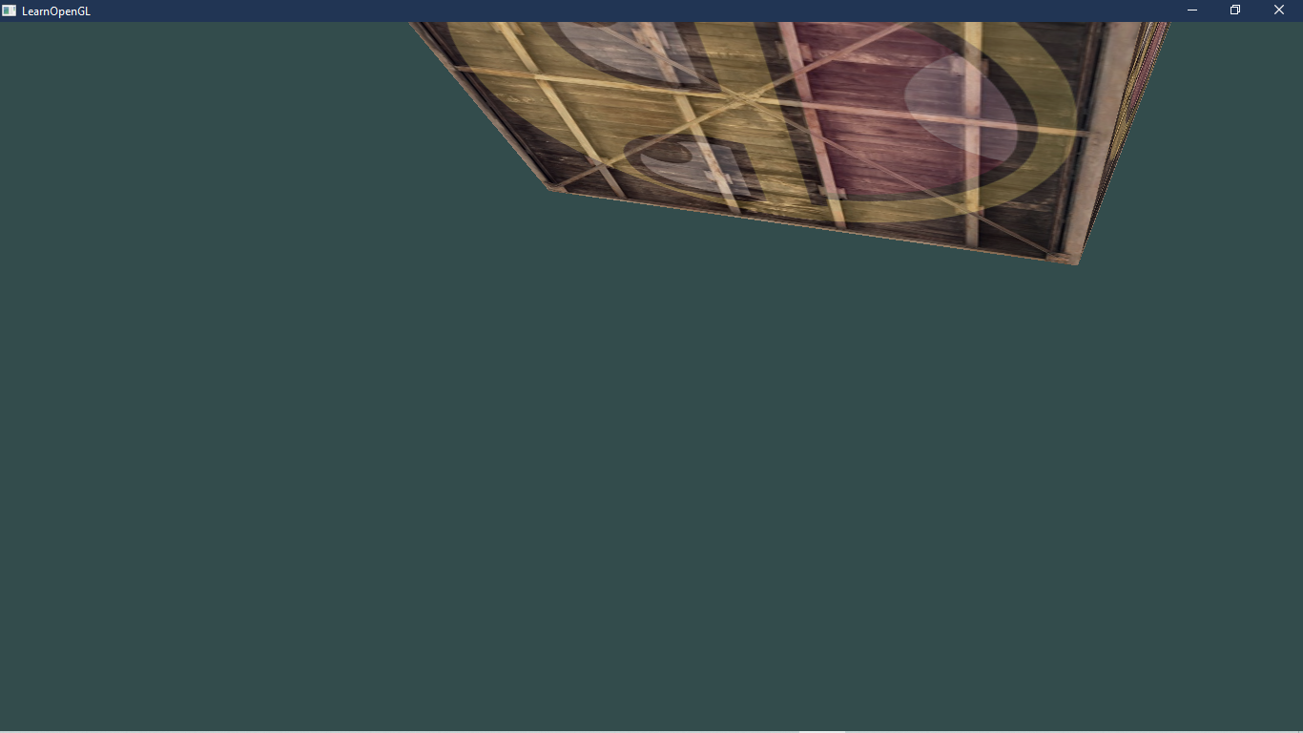

Lab Task Q3

Question:

Draw a Cube in OpenGL with 2 textures and control the mixture of texture using keyboard. You should be able to increase or decrease the opacity of second texture using keyboard. Use "w" for increase and "d" for decrease.

Solution:

## Main Program:

|  |
| --- |
| #*include* "glad.h"  #*include* "glfw3.h"  //*Roll: 1703018*  //*Q3: Draw a Cube in OpenGL with 2 textures and control the mixture of texture using keyboard. You should be able to increase or decrease the opacity of second texture using keyboard. Use "w" for increase and "d" for decrease.*  #*define* *STB_IMAGE_IMPLEMENTATION*  #*include* "stb_image.h"  // *#include "learnopengl/filesystem.h"*  #*include* "learnopengl/shader_s.h"  #*include* <iostream>  void *framebuffer_size_callback*(GLFWwindow*\** window, int width, int height);  void *processInput*(GLFWwindow *\**window);  // *settings*  *const* unsigned int SCR_WIDTH = 800;  *const* unsigned int SCR_HEIGHT = 600;  // *stores how much we're seeing of either texture*  **float mixValue = 0.2f;**  int *main*()  {  // *glfw: initialize and configure*  // *------------------------------*  *glfwInit*();  *glfwWindowHint*(*GLFW_CONTEXT_VERSION_MAJOR*, 3);  *glfwWindowHint*(*GLFW_CONTEXT_VERSION_MINOR*, 3);  *glfwWindowHint*(*GLFW_OPENGL_PROFILE*, *GLFW_OPENGL_CORE_PROFILE*);  #*ifdef* __APPLE__  *glfwWindowHint*(GLFW_OPENGL_FORWARD_COMPAT, GL_TRUE);  #*endif*  // *glfw window creation*  // *--------------------*      GLFWwindow* window = *glfwCreateWindow*(SCR_WIDTH, SCR_HEIGHT, "LearnOpenGL", *NULL*, *NULL*);  *if* (window == *NULL*)      {          std::cout *<<* "Failed to create GLFW window" *<<* std::*endl*;  *glfwTerminate*();  *return* -1;      }  *glfwMakeContextCurrent*(window);  *glfwSetFramebufferSizeCallback*(window, *framebuffer_size_callback*);  // *glad: load all OpenGL function pointers*  // *---------------------------------------*  *if* (!*gladLoadGLLoader*((GLADloadproc)*glfwGetProcAddress*))      {          std::cout *<<* "Failed to initialize GLAD" *<<* std::*endl*;  *return* -1;      }  // *build and compile our shader zprogram*  // *------------------------------------*      Shader *ourShader*("src/shader/4.2.texture.vs", "src/shader/4.2.texture.fs");  // *set up vertex data (and buffer(s)) and configure vertex attributes*  // *------------------------------------------------------------------*      float vertices[] = {  // *positions          // colors           // texture coords*           0.5f,  0.5f, 0.0f,   1.0f, 0.0f, 0.0f,   1.0f, 1.0f,// *top right*           0.5f, -0.5f, 0.0f,   0.0f, 1.0f, 0.0f,   1.0f, 0.0f,// *bottom right*          -0.5f, -0.5f, 0.0f,   0.0f, 0.0f, 1.0f,   0.0f, 0.0f,// *bottom left*          -0.5f,  0.5f, 0.0f,   1.0f, 1.0f, 0.0f,   0.0f, 1.0f// *top left*      };      unsigned int indices[] = {          0, 1, 3,// *first triangle*          1, 2, 3// *second triangle*      };      unsigned int VBO, VAO, EBO;  *glGenVertexArrays*(1, &VAO);  *glGenBuffers*(1, &VBO);  *glGenBuffers*(1, &EBO);  *glBindVertexArray*(VAO);  *glBindBuffer*(*GL_ARRAY_BUFFER*, VBO);  *glBufferData*(*GL_ARRAY_BUFFER*, sizeof(vertices), vertices, *GL_STATIC_DRAW*);  *glBindBuffer*(*GL_ELEMENT_ARRAY_BUFFER*, EBO);  *glBufferData*(*GL_ELEMENT_ARRAY_BUFFER*, sizeof(indices), indices, *GL_STATIC_DRAW*);  // *position attribute*  *glVertexAttribPointer*(0, 3, *GL_FLOAT*, *GL_FALSE*, 8 * sizeof(float), (void*)0);  *glEnableVertexAttribArray*(0);  // *color attribute*  *glVertexAttribPointer*(1, 3, *GL_FLOAT*, *GL_FALSE*, 8 * sizeof(float), (void*)(3 * sizeof(float)));  *glEnableVertexAttribArray*(1);  // *texture coord attribute*  *glVertexAttribPointer*(2, 2, *GL_FLOAT*, *GL_FALSE*, 8 * sizeof(float), (void*)(6 * sizeof(float)));  *glEnableVertexAttribArray*(2);  // *load and create a texture*  // *-------------------------*      unsigned int texture1, texture2;  // *texture 1*  // *---------*  *glGenTextures*(1, &texture1);  *glBindTexture*(*GL_TEXTURE_2D*, texture1);  // *set the texture wrapping parameters*  *glTexParameteri*(*GL_TEXTURE_2D*, *GL_TEXTURE_WRAP_S*, *GL_REPEAT*);// *set texture wrapping to GL_REPEAT (default wrapping method)*  *glTexParameteri*(*GL_TEXTURE_2D*, *GL_TEXTURE_WRAP_T*, *GL_REPEAT*);  // *set texture filtering parameters*  *glTexParameteri*(*GL_TEXTURE_2D*, *GL_TEXTURE_MIN_FILTER*, *GL_LINEAR*);  *glTexParameteri*(*GL_TEXTURE_2D*, *GL_TEXTURE_MAG_FILTER*, *GL_LINEAR*);  // *load image, create texture and generate mipmaps*      int width, height, nrChannels;  *stbi_set_flip_vertically_on_load*(true);// *tell stb_image.h to flip loaded texture's on the y-axis.*  // *The FileSystem::getPath(...) is part of the GitHub repository so we can find files on any IDE/platform; replace it with your own image path.*      unsigned char *data = *stbi_load*("resources//textures//container.jpg", &width, &height, &nrChannels, 0);  *if* (data)      {  *glTexImage2D*(*GL_TEXTURE_2D*, 0, *GL_RGB*, width, height, 0, *GL_RGB*, *GL_UNSIGNED_BYTE*, data);  *glGenerateMipmap*(*GL_TEXTURE_2D*);      }  *else*      {          std::cout *<<* "Failed to load texture" *<<* std::*endl*;      }  *stbi_image_free*(data);  // *texture 2*  // *---------*  *glGenTextures*(1, &texture2);  *glBindTexture*(*GL_TEXTURE_2D*, texture2);  // *set the texture wrapping parameters*  *glTexParameteri*(*GL_TEXTURE_2D*, *GL_TEXTURE_WRAP_S*, *GL_REPEAT*);// *set texture wrapping to GL_REPEAT (default wrapping method)*  *glTexParameteri*(*GL_TEXTURE_2D*, *GL_TEXTURE_WRAP_T*, *GL_REPEAT*);  // *set texture filtering parameters*  *glTexParameteri*(*GL_TEXTURE_2D*, *GL_TEXTURE_MIN_FILTER*, *GL_LINEAR*);  *glTexParameteri*(*GL_TEXTURE_2D*, *GL_TEXTURE_MAG_FILTER*, *GL_LINEAR*);  // *load image, create texture and generate mipmaps*      data = *stbi_load*("resources//textures//awesomeface.png", &width, &height, &nrChannels, 0);  *if* (data)      {  // *note that the awesomeface.png has transparency and thus an alpha channel, so make sure to tell OpenGL the data type is of GL_RGBA*  *glTexImage2D*(*GL_TEXTURE_2D*, 0, *GL_RGB*, width, height, 0, *GL_RGBA*, *GL_UNSIGNED_BYTE*, data);  *glGenerateMipmap*(*GL_TEXTURE_2D*);      }  *else*      {          std::cout *<<* "Failed to load texture" *<<* std::*endl*;      }  *stbi_image_free*(data);  // *tell opengl for each sampler to which texture unit it belongs to (only has to be done once)*  // *-------------------------------------------------------------------------------------------*      ourShader.*use*();// *don't forget to activate/use the shader before setting uniforms!*  // *either set it manually like so:*  *glUniform1i*(*glGetUniformLocation*(ourShader.ID, "texture1"), 0);  // *or set it via the texture class*      ourShader.*setInt*("texture2", 1);  // *render loop*  // *-----------*  *while* (!*glfwWindowShouldClose*(window))      {  // *input*  // *-----*  *processInput*(window);  // *render*  // *------*  *glClearColor*(0.2f, 0.3f, 0.3f, 1.0f);  *glClear*(*GL_COLOR_BUFFER_BIT*);  // *bind textures on corresponding texture units*  *glActiveTexture*(*GL_TEXTURE0*);  *glBindTexture*(*GL_TEXTURE_2D*, texture1);  *glActiveTexture*(*GL_TEXTURE1*);  *glBindTexture*(*GL_TEXTURE_2D*, texture2);  // *set the texture mix value in the shader*          ourShader.*setFloat*("mixValue", mixValue);  // *render container*          ourShader.*use*();  *glBindVertexArray*(VAO);  *glDrawElements*(*GL_TRIANGLES*, 6, *GL_UNSIGNED_INT*, 0);  // *glfw: swap buffers and poll IO events (keys pressed/released, mouse moved etc.)*  // *-------------------------------------------------------------------------------*  *glfwSwapBuffers*(window);  *glfwPollEvents*();      }  // *optional: de-allocate all resources once they've outlived their purpose:*  // *------------------------------------------------------------------------*  *glDeleteVertexArrays*(1, &VAO);  *glDeleteBuffers*(1, &VBO);  *glDeleteBuffers*(1, &EBO);  // *glfw: terminate, clearing all previously allocated GLFW resources.*  // *------------------------------------------------------------------*  *glfwTerminate*();  *return* 0;  }  // *process all input: query GLFW whether relevant keys are pressed/released this frame and react accordingly*  // *---------------------------------------------------------------------------------------------------------*  void *processInput*(GLFWwindow *\**window)  {  ***if* (*glfwGetKey*(window, *GLFW_KEY_ESCAPE*) == *GLFW_PRESS*)**  ***glfwSetWindowShouldClose*(window, true);**  ***if* (*glfwGetKey*(window, *GLFW_KEY_W*) == *GLFW_PRESS*)**  **{**  **mixValue += 0.001f;// *change this value accordingly (might be too slow or too fast based on system hardware)***  ***if*(mixValue >= 1.0f)**  **mixValue = 1.0f;**  **}**  ***if* (*glfwGetKey*(window, *GLFW_KEY_D*) == *GLFW_PRESS*)**  **{**  **mixValue -= 0.001f;// *change this value accordingly (might be too slow or too fast based on system hardware)***  ***if* (mixValue <= 0.0f)**  **mixValue = 0.0f;**  **}**  }  // *glfw: whenever the window size changed (by OS or user resize) this callback function executes*  // *---------------------------------------------------------------------------------------------*  void *framebuffer_size_callback*(GLFWwindow*\** window, int width, int height)  {  // *make sure the viewport matches the new window dimensions; note that width and*  // *height will be significantly larger than specified on retina displays.*  *glViewport*(0, 0, width, height);  } |

## Fragment Shader:

|  |
| --- |
| #version 330 core  out vec4 FragColor;  *in* vec3 ourColor;  *in* vec2 TexCoord;  **uniform float mixValue;**  *// texture samplers*  uniform sampler2D texture1;  uniform sampler2D texture2;  void main()  {  *// linearly interpolate between both textures (80% container, 20% awesomeface)*  *//FragColor = mix(texture(texture1, TexCoord), texture(texture2, TexCoord), 0.2);*  **FragColor = mix(texture(texture1, TexCoord), texture(texture2, TexCoord), mixValue);**  *// horizontal mirror*    } |

Output: